Custom ChatGPT of your knowledge Base

**24-FYP-202**



**Session 2020-2024**

**BACHELOR OF SCIENCE**

**IN**

**SOFTWARE ENGINEERING**

**SUBMITTED BY**

Muhammad Subhan Ud Din 20-NTU-CS-1129

Saad Usman 20-NTU-CS-1134

Sufyan Ahmad 20-NTU-CS-1135

**SUPERVISED BY**

Supervisor: Dr. Isma Hamid

Co-Supervisor: Mr. Arsal Mehmood

**Department of Computer Science**

**National Textile University, Faisalabad**

**CERTIFICATE**

This synopsis written by **Muhammad Subhan Ud Din (20-NTU-CS-1129), Saad Usman   
(20-NTU-CS-1134),** **Sufyan Ahmad (20-NTU-CS-1135)** under the direction of their supervisors and approved by all the members of the synopsis committee, has been presented to and accepted by the Director, Graduate Studies, and Research, in the partial fulfillment of the requirement of the Degree of Bachelor of Science in Software Engineering.

**Supervisor** ___________________ _____________

Dr. Isma Hamid Signature Date

**Co-Supervisor** ___________________ _____________

Mr. Arsal Mehmood Signature Date

**Internal Examiner** ___________________ _____________

Signature Date

**External Examiner** ___________________ _____________

Signature Date

**FYP Convener** ___________________ _____________

Muhammad Shahid Signature Date

**Head of Department** ___________________ _____________

Dr. Muhammad Asif Signature Date

**DECLARATION**

We hereby declare that this document is completely written by us, and it is totally our effort and none of anyone from outside of our group have copied it. This Report is purely written in a technical way in accordance with our project.

**Group Members:**

Mr. Subhan Ud Din ___________________ _____________

20-NTU-CS-1129 Signature Date

E-Mail: Subhandin1129@gmail.com

Mr. Saad Usman ___________________ _____________

20-NTU-CS-1134 Signature Date

E-Mail: saadchawla34@gmail.com

Mr. Sufyan Ahmad ___________________ _____________

20-NTU-CS-1135 Signature Date

E-Mail: sufianjellani@gmail.com

**Abstract:**

A Custom GPT that can be embedded in any website. The project addressed the limitations of existing generic Custom GPT’s by training the chatbot on a variety of data sources specific to the needs of each business. The chatbot also included features such as chat history management, multiple chat creation, plan changes to increase the knowledge base character limit, lead generation, and whitelisting domains. The chat bot is shareable with anyone and can be linked to CRM platforms.

**Table of Contents**

**DECLARATION** 3

**List of Figures** 8

**List of Tables** 9

CHAPTER 1 10

Introduction 10

1.1: Background: 10

1.2: Introduction: 10

1.3: Purpose: 13

1.4: Problem Statement: 14

1.5: Project goal: 14

1.6: Project Objectives: 15

1.7: Project Scope: 15

1.8: Types of Risks: 17

1.9: Risk in Development step: 20

1.10: Project Planning: 22

CHAPTER 2 25

Literature Review 25

2.1: Related Work: 25

2.2: Area of Studies: 26

2.3: Reason of development: 28

CHAPTER 3 31

System Requirements 31

3.1: Requirement Elicitation: 31

3.2: Functional Requirements: 33

3.3: Non-Functional Requirements: 35

3.4: Application User: 35

CHAPTER 4 37

Methodology 37

4.1: Methodologies for Software Development: 37

4.2: Existing Methodologies: 37

4.3: Selected Methodology 38

4.4: Reasons to use Agile Methodology: 39

4.5: Reasons to use Spiral Model: 40

CHAPTER 5 41

Architecture Design 41

5.1: Introduction to System Design: 41

5.2: Use Case Diagram: 42

5.3: ERD 45

5.5: Sequence Diagram: 47

CHAPTER 6 49

System Implementation 49

6.1. System Tools and Technology 49

6.1.1. VS CODE 49

6.1.2. NAVICAT 50

6.2. Class Diagram 50

6.2. Deployment Diagram 52

CHAPTER 7 53

System Testing 53

7.1 White Box Testing: 53

7.2 Black box Testing: 54

7.3: Verification 55

7.4: Validation 55

7.5: Adopted Methodology 55

7.6. Test Cases 58

CHAPTER 8 60

Application Prototype 60

8.1: Home Page: 60

8.2: Login Page: 60

8.3: Forget Password: 61

8.4: Reset Password: 62

8.5: Contact: 62

8.6: Pricing: 63

8.7: Training: Upload files: 63

8.8: Training 🡪 Add Text: 64

8.9: Training 🡪 Scrape Website: 64

8.10: Training🡪Transcribe YouTube: 65

8.11: Training 🡪 Personality of Bot: 65

8.12: Training: Unanswered Questions: 66

8.13: Settings: 66

8.14: Appearance: 67

8.15 Opt-in IN: 67

8.16 Share Bot: 68

8.17: Leads: 69

8.18: Chat History: 69

8.19: My Account: 70

8.20: Payments: 72

8.21 Create New Bot: 72

References 73

# **List of Figures**

Figure 1. 1***:*** Gantt Chart 24

Figure 4. 1 Agile Methodology 39

Figure 4. 2 Spiral Model 40

Figure 5. 1: User Use-Case 42

Figure 5. 2: Admin Use-Case 43

Figure 5. 3: Chat-Bot 44

Figure 5. 4: ERD1 45

Figure 5. 5: ERD2 46

Figure 5. 6: Sequence Diagram 48

Figure 6. 1: Class Diagram 51

Figure 6. 2: Deployment Diagram 52

Figure 7. 1: Black Box Testing 54

Figure 7. 2: Adopted Methodology 57

Figure 8. 1: Home Page 60

Figure 8. 2: Login Page 61

Figure 8. 3: Forget Password 61

Figure 8. 5: Reset Password 62

Figure 8. 6: Contact 62

Figure 8. 7: Pricing 63

Figure 8. 8: Upload Files 63

Figure 8. 9: Training Add Text 64

Figure 8. 10: Training Scrape Website 64

Figure 8. 11: Training Transcribe YouTube 65

Figure 8. 12: Training Personality of Bot 65

Figure 8. 13: Training: Unanswered Questions 66

Figure 8. 14: Settings 66

Figure 8. 15: Appearance 67

Figure 8. 16: Opt-in IN 67

Figure 8. 17: Share Bot: Embed and Share 68

Figure 8. 18: Share Bot: Whitelisted Websites 68

Figure 8. 19: Leads 69

Figure 8. 20: Chat History 69

Figure 8. 21: My Account – Billing 70

Figure 8. 22: My Account - Billing (Basic) 70

Figure 8. 23: My Account - Billing (Credits) 71

Figure 8. 24: My Account - Profile 71

Figure 8. 25: Payments 72

Figure 8. 26: Create New Bot 72

# **List of Tables**

Table 1. 1: Project Planning Table 23

Table 7. 1: Test Case for File-Based Training 58

Table 7. 2: Test Case for Web Scraping Training 58

Table 7. 3: Test Case for YouTube Integration Interface 59

Table 7. 4: Test Case for Embedding Widget Module 59

# CHAPTER 1

# Introduction

## 1.1: Background:

To adapt to the growing digital environment, the presented concept suggests developing a unique GPT. One of the problems that businesses must measure up to is offering immediate and tailored support to their clients. This gap can be filled by our solution that proposes the Al-powered custom GPT that can be easily integrated with any software.

This custom GPT is trained finely on various data sources and facilitated with some additional features like management of chat history, multiple custom GPT generation, increasing character limit, lead generation and setting the domain whitelist. It is social by nature, enabling businesses to take it further afield and utilize it in different ways. Further, integrate with CRM programs, and provide API services to any customer besides improving customer interaction and communications. This project aims to redesign how customer support and interaction work, assisting companies in the new economy.

## 1.2: Introduction:

Custom GPT is an Artificial Intelligence conversational model designed uniquely for the different tasks, the interaction, or even the field of an industry. It is used for exploring information in specific areas of interest to get solutions, advice or details in specific fields. Custom GPT can be well-trained and can understand the context of the words spoken in various sectors ranging from customer service, education, healthcare, etc. The model I proposed for the customer support subscription service will enable the automated system to be specific within the limit of the subscription service to be offered to subscriber customers. This specialized training enables it to respond to queries or tasks for a specific domain with better and more suitable answers compared to the general approach.

Absolutely! Custom GPT signifies Generic Pretrained Transform model that is used for a particular need or domain. Here's a more detailed breakdown: Here’s a more detailed breakdown:

#### Tailored Training:

* **Domain-Specific Expertise:**

It goes through a process of training using specific datasets peculiar to specific domains such as, for instance, the medical field, commerce, education, etc.

* **Customized Data Feeding:**

It is an application trained on data related to the more specific tasks or information that form the context of the input and output data, therefore is better suited than NLTK, for example, to understand contextual language.

* **Fine-Tuning Capabilities:**

It can therefore be updated from time to time depending on new data that may be generated or requirements from other fields that may have developed or shifted over time.

#### Specialized Functionality:

* **Contextual Understanding:**

It understands the related industry terms and phrases, and even the prevailing situation, to provide more precise answers.

* **Task-Specific Performance:**

It is best suited for tasks inherent in its specialty like identifying signs and symptoms in medicine, calculating and analyzing value in banking and finance, or dispensing legal support.

* **Industry-Grade Support:**

Offers tailored solutions for customer support, sales assistance, education, etc., enhancing user experience within that fi Provides a customized service delivery for customer services, sales, support, education etc. making the use of the product more enhanced within the area of interest.

1. **Benefits:**

* **Accuracy and Precision:**

Focus on specific area and ensures that it provides correct and right data within that sphere, thereby minimizing potential of making errors.

* **Enhanced User Engagement:**

Provision of more relevant content relativity to the targeted topic compared to the general information given in IM.

* **Efficiency and Productivity:**

Saves time on tasks or offers the quick right answers that make up for lack of perfect and personal efficiency elsewhere.

1. **Continuous Improvement:**

* **Adaptive Learning:**

Adaptive, adjusts to user interactions and modifies its response strings or behaviors depending on what it has been told or has learnt.

* **Scalability:**

Can be generalized to address larger segments of a certain domain or modified to fit other specific functional types within the same domain.

## 1.3: Purpose:

1. **Domain-Specific Assistance:**

* **Industry Relevance:** Strictly designed according to the nature of a specific area like medical, financial, client relations, teaching, etc.
* **Accurate Responses:** Provides specific, contextual data in its domain and improves the quality of aid, though lacks general information and wide topical coverage.

1. **Enhanced User Experience:**

* **Personalized Interactions:** Engages users with customized responses and solutions, catering to their specific needs or queries.
* **Efficient Support:** Helps reduce time spent and improve efficacy through fast, correct information or support, boosting satisfaction.

1. **Task Automation and Support:**

* **Automating Tasks:** Reduces the amount of working time that must be spent on repetitive tasks in a certain line of work to allow for more efficient usage of human resource addressing higher value-added processes.
* **Handling Queries:** Minimizes the hassles of noting frequent inquiries or typical exercises executed in organizations to achieve the set goals and objectives.

1. **Continuous Improvement and Adaptability:**

* **Adaptive Learning:** Absorbs from the interactions and learns from the users and adds to its knowledge base with furthermore improved performance.
* **Scalability:** Extensible, this may be extended to address new areas within the same domain or sociotechnical requirements.

1. **Industry-Specific Applications:**

* **Customer Support:** Can respond to specific queries or concern in the requested areas of specialization within a particular industry or organization.
* **Education:** Can respond to specific queries or concern in the requested areas of specialization within a particular industry or organization.
* **Healthcare:** Provides consultations on medical conditions, signs, and/or any issues pertaining to health.
* **Finance:** Involve giving of financial information such as on the right way on how to manage financial matters, investing, etc. in the financial sector.

## 1.4: Problem Statement:

Most companies use Custom GPT to address clients’ concerns and inquiries, among other services. However, most of the Custom GPT are general, and they do not focus on the requirements needed for the individual company. This could be a very unfruitful experience for customers such that they feel like they are wasting their time and as well, a negative experience for the business entities. Within the new interface there is no Leads, CRM (Customer Relationship Management), Chat History, or Share option and does not have multiple routes to train your Custom GPT.

## 1.5: Project goal:

Engaging in the creation of a Custom GPT that can be modified as required for integration on a website, having noticed shortcomings in many general Custom GPT’s. The chat bot as such has customizability to various businesses and the components of it include chat history control, ability to handle multiple chats at the same time, the ability to add more to the knowledge base, lead capturing and domain banning. It underlines flexibility of the project for different types of industries, possibility to share documents and their integration with CRM platforms such as WhatsApp. The management’s vision is to offer an all-in-one conversational AI to businesses that can help them create a better user experience for their customers and in turn enable them to enhance customer interactions, automate processes and generate leads.

## 1.6: Project Objectives:

The following are the main objective of this study.

* To Develop a custom GPT that can be embedded in any website.
* To Train the Custom GPT on a variety of data sources, including text files, website links, YouTube transcripts, and payment methods.
* To Add features such as chat history management, multiple Custom GPT creation, plan changes to increase the knowledge base character limit, lead generation, and whitelisting domains.
* To Make Custom GPT shareable with anyone.
* To Linked with CRM (WhatsApp and Api)

## 1.7: Project Scope:

1. **Industry Expertise:**

* **Healthcare:** It involves identifying symptoms, informing patients and helping with health problems and questions.
* **Finance:** Provide, shares and provides further information on money management, financial planning, and investment.
* **Customer Support:** To address questions, assist, and provide technical or client support on products or services.
* **Education:** Teaching sessions, clarifications, and individual treatments or instructions.
* **Technology:** Being a technical helper in explaining technical issues, clearing doubts, or suggesting technical products/services.
* **Legal:** In this context, legal facts, definitions of legal terms, and navigation through basic legal processes can be given.

1. **Functionalities:**

* **Information Retrieval:** Retrieving and delivering pertinent information within a particular field of specialization.
* **Task Automation:** Basic workflows and first-line support to tackle some repetitive tasks.
* **Language Understanding:** Understand and consider the subtleties, idioms, and other issues peculiar to a given field.

1. **Applications:**

* **Text-based Support:** Supporting human users through text channels, for example through a chat app or website.
* **Voice Assistants:** Offering voice-based services and product information.
* **Knowledge Databases:** Providing energy for the knowledge bases for specific industries or actions.
* **Workflow Integration:** It easily blends with other systems and/or processes for a smooth functioning of the organization.

1. **Scalability:**

* **Customization:** Teaching the system new forms of knowledge, which makes AI adaptable to new contexts or broadens its knowledge within a given field.
* **Adaptability:** Understanding the new data and the user interaction to update the search space and extend it as needed.

## 1.8: Types of Risks:

Contingencies are very significant elements in projects that are associated with software or building design. Some of the risks involved in this project are mentioned below:

* Data Privacy and Security Risks
* Bias and Ethical Concerns
* Integration Challenges
* Scalability Issues
* User Acceptance and Satisfaction
* Regulatory Compliance
* Technical Challenges
* Training Data Limitations
* Dependency on External Platforms
* Cost Overruns

1. **Data Privacy and Security Risks:**
   * **Risk:** This may be coupled with privacy risks if training or the interactions involve dealing with sensitive information.
   * **Mitigation:** Encrypt data at higher levels, follow the rules and regulations of data protection and security and perform security check as often as possible.
2. **Bias and Ethical Concerns:**

* **Risk:** It Post implementation issues include ethical considerations where the chat bot responds to request inappropriately or has biases.
* **Mitigation:** Use samples that are diverse and balanced in terms of their representation during the training process, incorporate tools that allow identifying biases, and analyze and update the content recommendations periodically.

1. **Integration Challenges:**

* **Risk:** Challenges in making the chatbot to interlink with the different websites and the CRM systems.
* **Mitigation:** Undergo extensive testing and perform exhaustive documentation and possible technical support during the implementation of the system.

1. **Scalability Issues:**

* **Risk:** This makes the system to be slow in adapting to many users or large volume of data.
* **Mitigation:** Ensure that the system can accommodate more users and think about using clouds and conduct a load test to establish problems.

1. **User Acceptance and Satisfaction:**

* **Risk:** hat can be seen in the ability of the system to accommodate number of users or data size.
* **Mitigation:** Try to plan the system to be gradually extensible, use cloud infrastructures, and conduct a load test to find out the points of possible congestion.

1. **Regulatory Compliance:**

* **Risk:** Any alteration of data protection or other regulations put in place for innovation in the use of artificial intelligence may influence the project.
* **Mitigation:** It is recommended that actors acquaint themselves with the current laws governing the given system and follow the laid down procedures when engaging themselves in the process.

1. **Technical Challenges:**

* **Risk:** Of unexpected technical problems in the work, defects, or incompatibilities inherent in the given solution.
* **Mitigation:** Execute comprehensive testing at each stage of development, incorporate efficient debugging procedure and to be free with the developers.

1. **Training Data Limitations:**

* **Risk:** To this end, one weakness associated with the chat bot system is that if the training data is either insufficient or unbiased, the efficiency of the chat bot is reduced significantly.
* **Mitigation:** Train the model on a set of diversified but relevant data and keep the data set relevant and recent and ensure that the model has a way of updating its data regularly.

1. **Dependency on External Platforms:**

* **Risk:** Use of external solutions (e. g., CRM systems) can become a weakness.
* **Mitigation:** Include the sources which should inform the updates from the external platform, ensure the system is built in such a way that can change with outside Platform, and have plans in the event of disruptions.

1. **Cost Overruns:**

* **Risk:** Expenditures resulting from elements that were not originally planned in the design or implementation stage.
* **Mitigation:** Create a more detailed forecast and keep spending under strict observation and control and define priorities regarding specific features according to the available resources.

## 1.9: Risk in Development step:

1. **Algorithmic Complexity:**

* **Risk:** The training of the model that the chat bot utilizes may be a process that takes a lot of time and calculation power.
* **Mitigation:** Scale up on-demand IT resources with cloud services, get a more efficient training process, and apply pre-trained ones if the training is time-consuming.

1. **Model Training Challenges:**

* **Risk:** Training the chat bot model may require extensive computational resources and time.
* **Mitigation**: Utilize cloud computing for scalable resources, optimize the training process, and consider pre-trained models to reduce training time.

1. **Integration Issues:**

* **Risk:** The main difficulty might be the ability to quickly and quietly accommodate the chat bot into the numerous sites and CRM systems.
* **Mitigation:** Create and provide documentation on how your application integrates with the other software, conduct cross-platform compatibility testing, and be available for consultation when the integration is to take place.

1. **Natural Language Understanding (NLU) Accuracy:**

* **Risk**: Since NLU will be somewhat inaccurate, the chat bot may mis-understand inputs from the user.
* **Mitigation:** On going improvement of the NLU model and using different sources of training data and feedback from the users to increase the accuracy.

1. **Scalability Challenges:**

* **Risk:** The system might have problems with an increase in the number of users or simultaneous conversations.
* **Mitigation:** This should be done with an eye on extensibility that will incorporate extension strategies, integration of cloud solutions, and load testing for discovering and solving scalability flaws.

1. **Resource Constraints:**

* **Risk:** Resources, including or excluding compiled programming code, general processing power, or the development time, may be a constraint.
* **Mitigation:** When there is a problem of limited resources, a business needs to prioritize the features and allocate the resources in the right way, and it also needs to find partners to share the resources.

1. **User Interface (UI) and User Experience (UX) Design:**

* **Risk:** Lack of good UI/UX design implies that the chat bot may not be easily understandable by the users and thus not easily operable.
* **Mitigation:** Include the UI/UX designers in a process of creating a layout, engage in a series of tests on the interface and design modifications that derived from the results of such testing.

1. **Data Quality Issues:**

* **Risk:** This means that misleading or partial information may be provided as training data, and this is undesirable.
* **Mitigation:** Incorporate multiple validation steps, make efforts to procure accurate training datasets, and ensure the further examination and revision of training data.

1. **Platform Compatibility**:

* **Risk:** The application of a chat bot may cause some compatibility problems with other browsers, devices or OS.
* **Mitigation:** Cross-browser and cross-device testing is crucial; solving compatibility problems until you have an ideal solution.

1. **Security Concerns:**

* **Risk:** In the free version some flaws can be seen, which is security problem particularly with user information.
* **Mitigation:** Ensure that strong security controls are put in place, carry out vulnerability assessments from time to time, and be familiar with the common current standards of security.

## 1.10: Project Planning:

Project planning is done by using tool Microsoft Project. We achieve our task completion within given time which is written in given table and display in the figure:

Table 1. 1: Project Planning Table

|  |  |  |  |  |
| --- | --- | --- | --- | --- |
| **Task Name** | **Duration** | **Start** | **Finish** | **Predecessors** |
| **Requirement**  **Gathering** | 15 days | Fri 9/15/23 | Thu 9/15/23 |  |
| **Requirement Analyses** | 20 days | Fri 10/6/23 | Thu 11/2/23 | 1 |
| **Project Proposal** | 10 days | Fri 11/3/23 | Thu 11/16/23 | 1,2 |
| **Database Design** | 12 days | Fri 11/17/23 | Mon 12/4/23 | 1,2,3 |
| **Architectural**  **Design** | 10 days | Tue 12/5/23 | Mon 12/18/23 | 1,2,3,4 |
| **Implementation** | 90 days | Tue 12/19/23 | Mon 4/22/24 | 1,2,3,4,5 |
| **Testing** | 30 days | Tue 4/23/24 | Mon 6/3/24 | 1,2,3,4,5,6 |
| **Final Deliverable** | 10 days | Tue 6/4/24 | Mon 6/17/24 | 1,2,3,4,5,6,7 |
| **Evaluation** | 30 days | Tue 6/18/24 | Mon 7/29/24 | 1,2,3,4,5,6,7,8 |

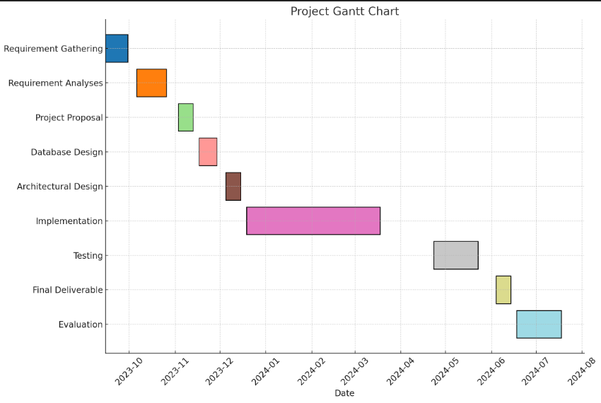

Figure 1. 1**:** Gantt Chart

# CHAPTER 2

# Literature Review

## 2.1: Related Work:

1. **Customizable Chatbot Platforms:**

Enumerate the current forms of automated interaction solutions that are unique and suitable for certain programs. It is about comparing the details of the offered customization, means of user-interaction, and capabilities for amalgamation with other systems.

1. **Industry-Specific Chatbot Implementations:**

Learn about some of the examples or studies on how chatbots have been used in different fields. Include cases where organizations have stood to gain from conversational UIs particularly in cases of customer relations, promotion or product information.

1. **CRM-Integrated Chat Systems:**

Search for research or initiatives that were made in the area of organization of chat systems with CRM applications. Examine how organizations can apply CRM-integrated chatbots to improve customer relations and the lead, and other related communication procedures.

1. **Advanced Chatbot Features:**

Find works or cases that present features that are not basic or standard for a chatbot. See how more elaborate features like Chat history, Leads, and collaboration features have been integrated to enhance the user experience.

1. **User-Driven Training in Chatbots:**

Discuss case when users are engaged in the training of chatbots. Research innovations that allow users to rate, make corrections or teach the chatbot new things pertaining to a certain domain.

1. **Collaborative Chat Systems:**

Identify other chat systems, which focus on collaboration and where the sharing options are available.

## 2.2: Area of Studies:

1. **Natural Language Processing (NLP):**

Basic comprehension of the methods of natural language processing and analysis is crucial. Acquaint with the approaches of Natural Language Processing, sentiment analysis and language modeling for improving the capability of the chatbot with respect to conversation.

1. **Machine Learning and AI:**

Utilize machine learning methods, especially those concerning the training and updating of a chatbot. Utilize AI approaches to increase the chatbot’s capacity to learn from users’ communication and develop with them.

1. **Data Science and Analytics:**

Apply big data methodologies to learn from a user’s use of the chatbot, especially to tweak the performance of the chatbot. For the assessment of the user activity and interaction, their tendencies and the performance of the chatbot’s answers, consider data analytics.

1. **Human-Computer Interaction (HCI):**

Stress the aspect of interface and the necessity for it to be as convenient as possible for the end-user of the chatbot. Locate principles of HCI to design a good user experience; this involves the use of such factors as accessibility, response time, and even ease of use.

1. **Software Development and Engineering:**

Adopt software engineering practices for the development of the chatbot system. This involves writing the source code and the program, compiling the code and creating the different versions of the program, and the processes that are used by different programmers in developing the program. Think about the code in terms of scalability and maintainability of the code.

1. **Web Development:**

Use the concept of incorporating the chatbot to websites. Find out the technologies, tools, frameworks, and practices for easy integration and operation in various Web contexts with Web development components.

1. **Database Management:**

Localize the storage and retrieval of the chat history, users’ preferences or other such data. Use Data Base management system to store and manipulate data.

1. **Security and Privacy:**

Another one concerns the inclusion of security aspects to prevent data leaks and meet privacy regulations. Familiarize with encryption techniques, ways of establishing secure connections and procedures for protecting AI-based systems.

1. **Customer Relationship Management (CRM):**

Research on the CRM platforms and learn how the chatbot can be linked to the common applications including WA, Slack and Messenger. Think about how the customers’ engagement can be-aligned with the organizational CRM applications.

1. **Business Process and Domain Analysis:**

Perform a detailed assessment of the business domain in order to understand the particular requirements and issues, which should be solved by the chatbot. Be aware of specific details in relation to the requirements of the industry concerning customer support and leads.

1. **Collaboration and Communication Platforms:**

Learn about integration options with interaction and communication. Explore how the chatbot can be integrated to work smoothly with other tools such as Slack and help in team cooperation.

## 2.3: Reason of development:

1. **Enhancing Customer Experience:**

The currently available domain-agnostic chatbots lead to the generation of applications that do not meet the client’s needs, but rather are of diminished quality for all. By having a modular Custom GPT, the chatbot was made to be customized for the businesses’ needs to make the engagement with the users more appealing.

1. **Meeting Unique Business Requirements:**

Various kinds of vendors and merchants have distinctive demands; thus, an ordinary chatbot will hardly meet them. Getting to the last advantage, it is equally important to note that the proposed Custom GPT can be modified to allow for industry-specific peculiarities, terminologies, and procedures that are critical in achieving the set business objectives by the chatbot with more efficacy.

1. **Improving Customer Support:**

Indeed, it is possible to observe that a big number of companies use chatbots for customer service. However, generic chatbots may lack ability of offering detailed and associated information. It is necessary to create an individual flexible Custom GPT with new functions, including chat history management and opportunities to use CRM, to improve the quality of customer support interactions.

1. **Optimizing Lead Generation:**

The incorporation of lead generation features into the chatbot helps the businesses not just in helping customers but also in gathering vital information regarding the leads. This functionality expands on what the chatbot does and steps up the proactive contribution to the business.

1. **Enabling Seamless Integration:**

Improve different platforms and channels of communication practiced in organizations. The Custom GPT fixes the issue of integration by enabling the chatbot to be placed on business’ websites and, in turn, integrating it with widely used CRM such as WhatsApp.

1. **Filling Gaps in Existing Solutions:**

It can be also important to state that the current chatbot solutions market might still be missing some features which could be vital when it comes to customers’ IP interactions. The gaps have not been addressed in competitors’ solutions, which is where your proposed project comes in: multiple chat creation, change of plans, and the option to share a chatbot at any given time means that your product is more diverse.

1. **Empowering Businesses with AI Technology:**

With AI at the center of operations across industries taking shape in the modern world, an offer to provide an enterprise with a customizable Custom GPT means to turn wheels in AI-driven conversational agents entirely to the enterprise’s benefit. This could consequently lead to improved workflow, good relations between the managers and the customers as well as between the managers themselves.

1. **Facilitating User Training and Collaboration:**

The proposed Custom GPT model has considered the use involvement in its framework through accommodating the multiple option training and integration of collaborative features in its training design. It can be concluded that businesses can play an active role of participating in the process of learning for the chatbot and ensuring maximal accordance with the needs and knowledge of the business.

1. **Addressing Limitations of Generic Chatbots:**

Specific types of Chatbots can perhaps be less versatile and less robust when it comes to getting others done. Thus, your project seeks to eliminate these drawbacks by presenting an exceptionally flexible and scalable chatbot solution that can be fine-tuned to meet the changing needs of businesses.

1. **Promoting Innovation in Conversational AI:**

While the creation of a Custom GPT can easily fulfill present business requirements, there is more to the process than just that: The future of conversational AI is a constantly unfolding story that will benefit from a flexible Custom GPT. The project idea of your work is to perform challenging objectives for the modern AI chatbot and set higher benchmarks.

# CHAPTER 3

# System Requirements

## 3.1: Requirement Elicitation:

1. **Stakeholder Identification:**

Determine all the target clients, merchants, programmers, and any other individuals who will be affected by or likely to influence the project.

1. **Conducting Stakeholder Interviews:**

Allow any key stakeholder to describe to you their mission, their vision, their expectations, and the requirements that they may have for the fun and creative customizable Custom GPT. Desiring an understanding of the desired functionalities, the users’ interactions, and integration with the system.

1. **Surveys and Questionnaires:**

Sent surveys or questionnaires to a larger populace where the respondent’s quantitative answers as to their needs, features, and utility of SW can be obtained.

1. **Domain Analysis:**

Explained the predictions of analysis common to the business domain to identify the industry-specific needs and issues solved by the chat bot.

1. **Use Case Definition:**

Specified the use-cases of the chat bot and documented them properly along with the purpose of the chat bot. This entails specifics of when the chat bot would be applied in the form of customer care, marketing, or data acquisition among others.

1. **Functional Requirements:**

Analyses the research and identify and document the functional requirements of the chat bot. These are chat history and logs, multiple chat creation, changes in the plan, lead capture, and connecting to the CRM.

1. **Non-functional Requirements:**

Included non-functional requirements like performance, scalability, security, timeliness and much more.

1. **User Interface (UI) Design:**

Consulted the stakeholders about the specific requirements of the user interface. This is the aesthetics of the chat bot, the flow of operations that the user will be interacting with and additional icon and customization.

1. **Integration Requirements:**

Also, precisely indicate where the chat bot should be installed in different websites and the related CRM platforms such as WhatsApp, Slack, or Messenger. Describe the compatibility constraints and any API that will be called by the application.

1. **Data Handling and Privacy Requirements:**

Covered data management and protection issues. Determine what exactly is going to be done with the users’ data, where it is going to be stored and how it will be secured. This should be done while conforming to the juridical requirements of data protection in the country of operation.

1. **Performance Metrics:**

Set up the standards to measure the achievement of the chat bot which includes, the time taken to respond, and its efficiency and effectiveness. Set performance limits that would be tolerable depending on the intended application.

1. **Regulatory Compliance:**

Find out and record whether there are any rules mandated for the project with reference to protecting data and machine learning and AI ethics.

1. **Prototyping and Feedback:**

Create the first versions of the chat bot, whether in the form of skeleton mock-ups or preliminary versions to show to other stakeholders. Revise the design based on the results which have been obtained.

1. **Documentation:**

Record all the gathered requirements in a systematic requirement specification document. The document should be easily understood by all the shareholders of the company.

1. **Verification and Validation:**

It is necessary to create a procedure for requirements validation and checking the received data. This may include reviews, walkthroughs and validating activities such as validation with other stakeholders.

## 3.2: Functional Requirements:

Following are the functional requirements:

1. **Embeddable Chat Interface:**

* Custom GPT should have the convenience of the chat interface which should be able to be incorporated into any website or any platform.
* The interface for the application should be malleable in terms of physical appearance as well as operation.

1. **Training Data Variety:**

* Custom GPT should be trained with text file, URL link, you tube transcript and other related sources of data.
* It is suggested to update the training data from time to time as Custom GPT needs to be aware of current events and trends.

1. **Feature Set:**

* **Chat History Management:** Users should be able to have a summary of conversations that took place between both users and be able to view previous conversations.
* **Multiple Custom GPT Instances:** Backing for the development of at least two copies, for various reasons or for different departments.
* **Plan Changes:** To enhance the knowledge base character limit users should be allowed to change plans.
* **Lead Generation:** Inclusion of various lead generation modules to enter the user details for marketing or for selling purposes.
* **Domain Whitelisting**: Feature to whitelist domains that defines what sites Custom GPT can be placed and used at.

1. **Shareability:**

* Custom GPT should be easily distributable to any individual so that the users of this AI application can share the chat interface across different platforms and channels.

1. **CRM Integration:**

* Compatibility with the CRM tools such as WhatsApp and other API connectors that enables efficient flow of communication and data.

## 3.3: Non-Functional Requirements:

Following are the Non-functional requirements:

1. **Scalability:**

* Such a system should be able to successfully support tens, if not hundreds, of concurrent users and be expandable as necessary later.

1. **Performance:**

* Custom GPT should reply to the user’s requests within the shortest time possible to create a more natural interaction.

1. **Security:**

* This implies that proper security measures must be put into place to ensure that the data belonging to the users are secure.
* Meeting all the standards of data protection legislation, new and old, such as GDPR and the CCPA.

1. **Reliability:**

* An important factor of availability is that the system should be very dependable, experiencing low levels of unavailability.

1. **User Experience:**

* The graphical user interface should be well designed and easy to use in order to facilitate administrators and with end-users.

## 3.4: Application User:

1. **Website Owners/Administrators:**

* Responsible for embedding Custom GPT into their websites.
* Manage chat history, user data, and configurations.
* Monitor performance and usage metrics.

1. **End Users:**

* Visitors to the website who interact with Custom GPT for information, assistance, or support.
* Speak to someone and ask for the right help or advice from Custom GPT.
* Provide feedback on the conversational experience.

# CHAPTER 4

# Methodology

## 4.1: Methodologies for Software Development:

This line of work can never be complete without involving software development. The software development practice of dividing the development into small phases improved system design and programming design, implementation, integration testing, acceptance testing, and maintenance. If all phases are carried out, then the above project is considered to have been delivered.

Broadly, there are precedential types of methods that can be used in developing a project. It is crucial to choose a method for the development of a project and guarantee that the foreseen complexities will be worked through applying the selected methodology. Therefore, depending on the project, the methodology of software development is chosen. Each kind of methodology has something like risk in it, or there is something like testing of project in it.

The methodologies, and there are many, represent methods of organizing and conducting an academic study. The commonly applied methodologies are V model, spiral model, Scrum, incremental model, rapid application development and agile method.

## 4.2: Existing Methodologies:

Software development life cycle or SDLC, in general, gives an outline of all the procedures that go into the manufacturing of software. As for the idea of sequential development of the software, there are several methodologies. Software development is not only writing the code/programs, but it is several procedures, tasks, and phases to go through in creating a system or software in the best way. The methodologies detected in the study were also seen to increase the efficiency and the quality of a software product. Software can be produced without employing a methodology, but this impacts the results. The methodology will inform us of the performance, errors, and omission in each step that is being taken.

Many types of methodologies now exist but some of them are briefly introduced here:

* **Spiral Model**
* **Agile Model**

4.3: Selected Methodology**:**

After having detailed study, Hybrid methodology is selected for this this system to be built in an effective way. Hybrid methodology consists of:

* **Agile**
* **Spiral Model**

## 4.4: Reasons to use Agile Methodology:

That is why it is important to examine the reasons for using Agile Methodology:

* 1. **Flexibility:** Flexibility is the major strength of the agile system where it can easily learn, follow and address alterations in requirements and priorities.
  2. **Customer Involvement:** Feedback from the stakeholders is integrated right from the developmental stages.
  3. **Early Delivery:** Incremental releases allow the release of functionality to the user.
  4. **Transparency:** There are always meetings to inform people of things.
  5. **Collaboration:** Collaborative work is promoted due to cross functional teams, hence there is sharing of responsibility.
  6. **Risk Mitigation:** Some problems are solved in advance, which decreases project risks.

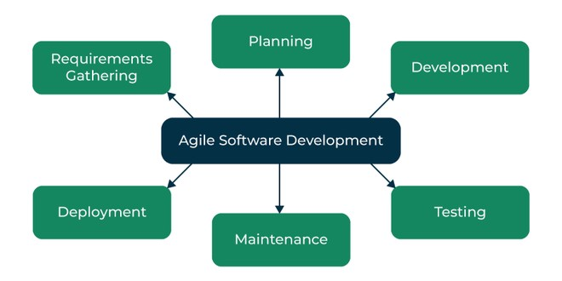

Figure 4. 1 Agile Methodology

## 4.5: Reasons to use Spiral Model:

* 1. **Risk Management:** Conducts risk assessment at the event identification stage.
  2. **Flexibility:** Is feasible as evolves throughout the process of development.
  3. **Customer Involvement:** Involves all the stakeholders at various levels.
  4. **Progressive Elaboration:** Enables progressive improvements as discussed below.
  5. **High Quality:** Is focused heavily on testing and analysis.
  6. **Suitable for Complexity:** These methodologies are ideal for undertaking large and complicated work/tasks.

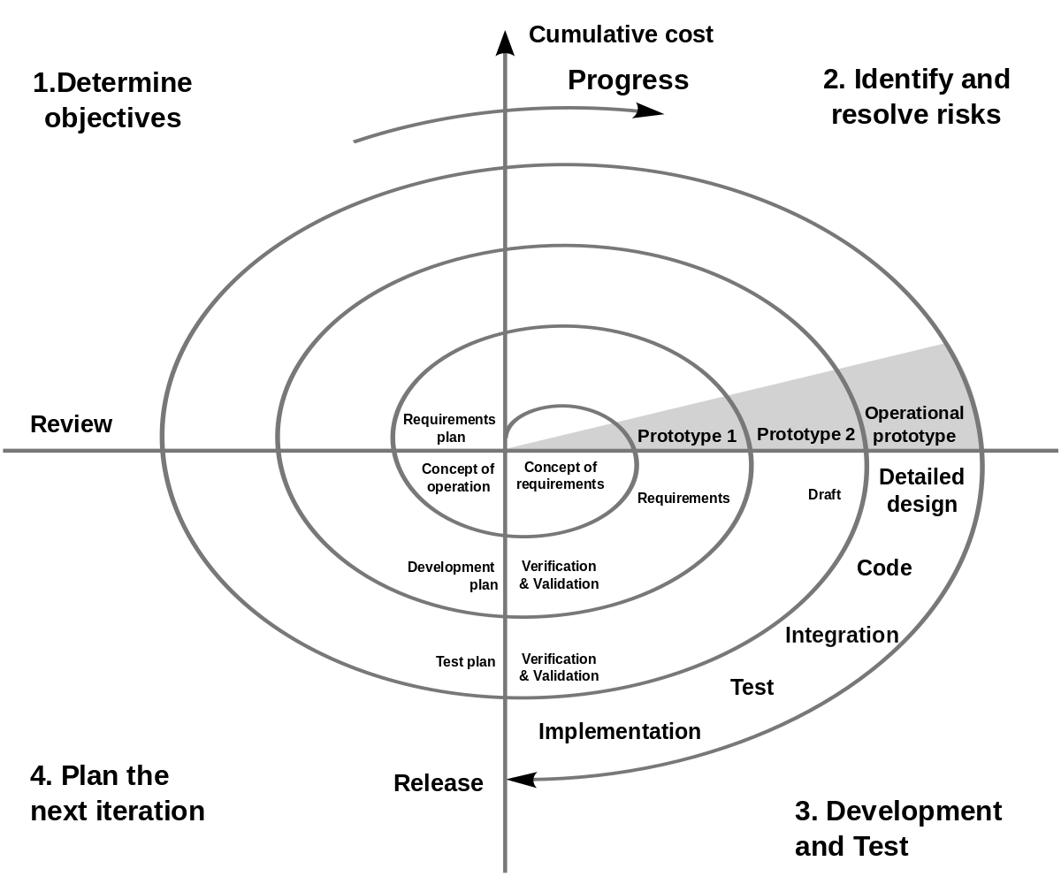

Figure 4. 2 Spiral Model

# CHAPTER 5

# Architecture Design

## 5.1: Introduction to System Design:

System design is the activity where the logical structure of a system, functions, parts, sub systems, their connections, and data requirements to meet specified criteria are determined. It will be seen that the disciplines of systems analysis, systems architecture, and systems engineering do have interfacing and interrelated features. More specifically, architectural design is used to define the general layout of the system especially for software.

The architecture of Custom GPT of your knowledge Base is described in this chapter

## 5.2: Use Case Diagram:

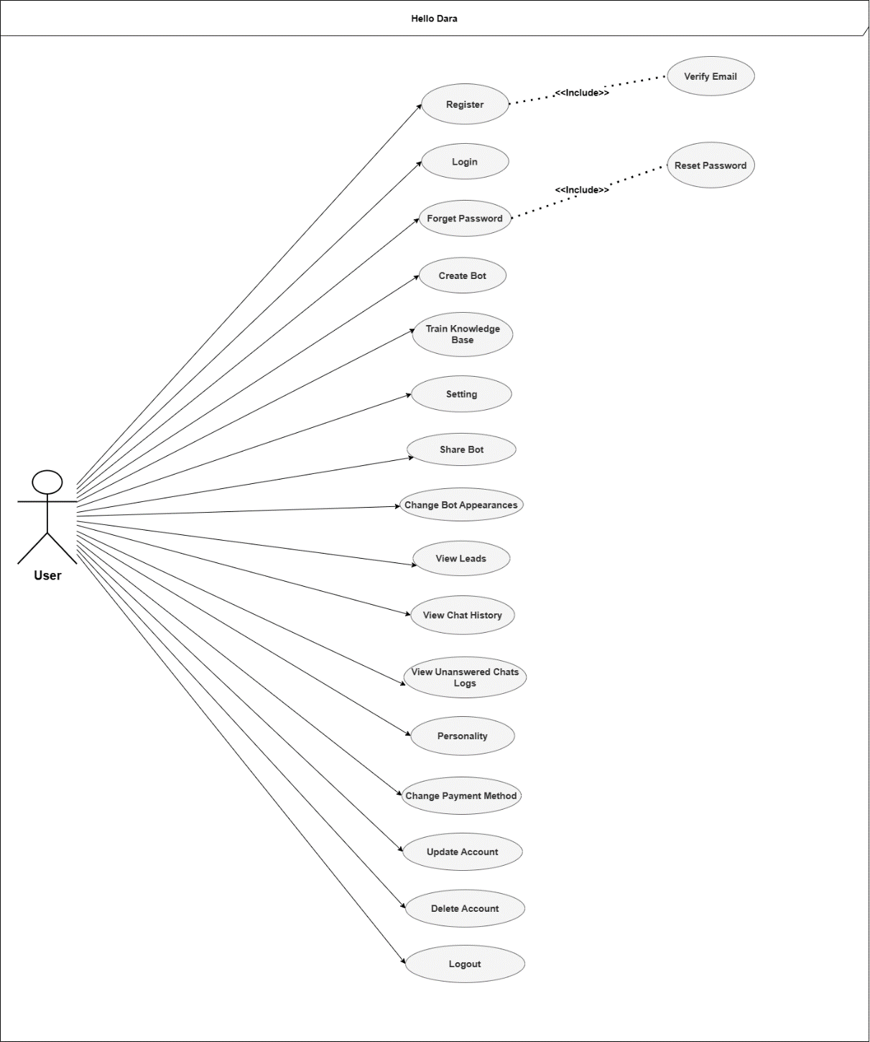The is a use case diagram with a user denoted as “User” or “Actor” on the left side. The user is connected by lines to multiple ovals representing various activities or actions the user can perform. This diagram illustrates the interactions between the user and a system, detailing different use cases like Login, Register, View Items, etc.

Figure 5. 1: User Use-Case

This UML Use Case Diagram showcasing interactions between a user (actor) and various system functionalities like “Create invoice,” “Process order,” and “Generate report.” Solid lines connect the actor to each use case, while dashed lines with and tags indicate dependencies, such as “remark order” being part of “Process order.” The system boundary encompasses all use cases, defining the system’s scope.

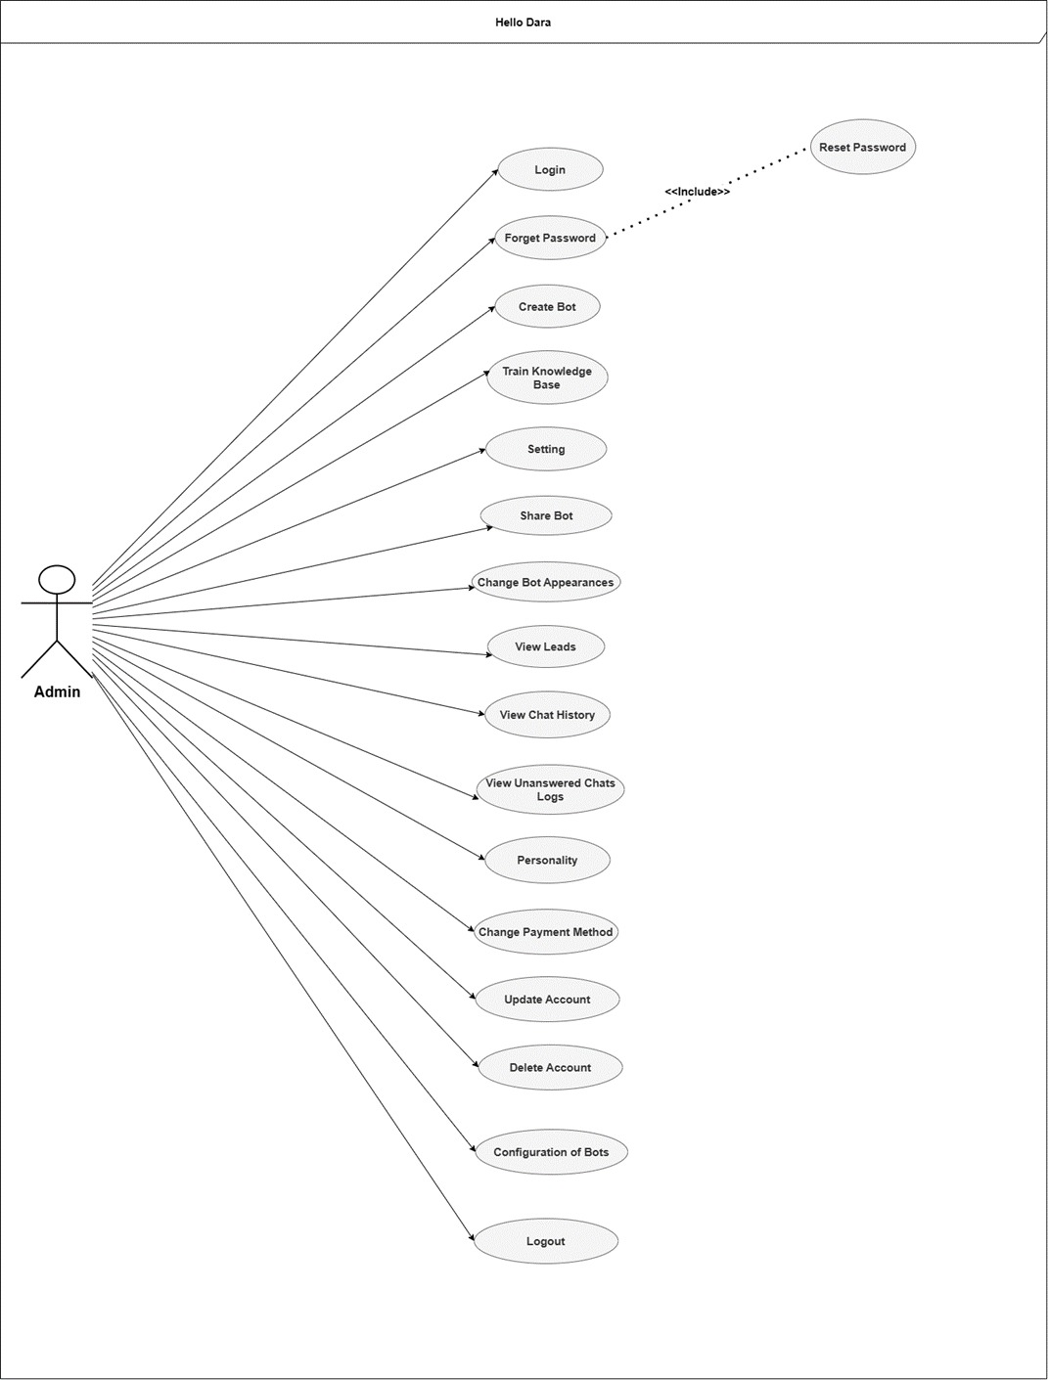

Figure 5. 2: Admin Use-Case

This use case diagram titled “Admin” showing two actions available to the user role “Creator.” The actions depicted are “Respond Question” and “Manage Credits,” each represented as ovals and connected to the “Creator” with dotted lines. The “Creator” user is depicted as a stick figure icon.

Figure 5. 3: Chat-Bot

## 5.3: ERD

The diagram depicts an entity-relationship model connecting various data entities such as users, addresses, items, packages, and orders. It details relationships between entities, including user permissions, addresses, item types, and messages. This visual representation highlights the structure and interaction of database components.

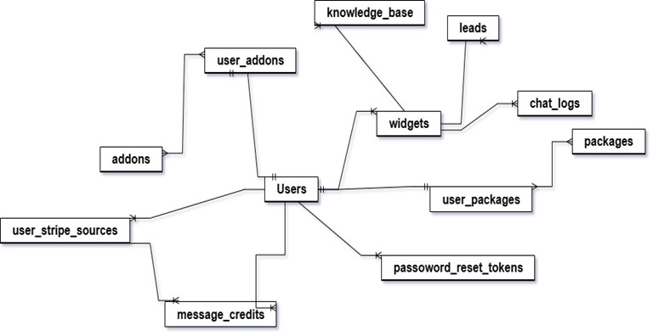

Figure 5. 4: ERD1

Figure 5. 5: ERD2

## 5.5: Sequence Diagram:

This is a sequence diagram showing doctors and user interactions. It details the flow of actions such as login, managing prescriptions, and creating appointments. The vertical lines represent different actors (Admin, User, and Doctor), while horizontal arrows illustrate the interactions and method calls between them. The diagram maps the sequence of operations in a healthcare application system.

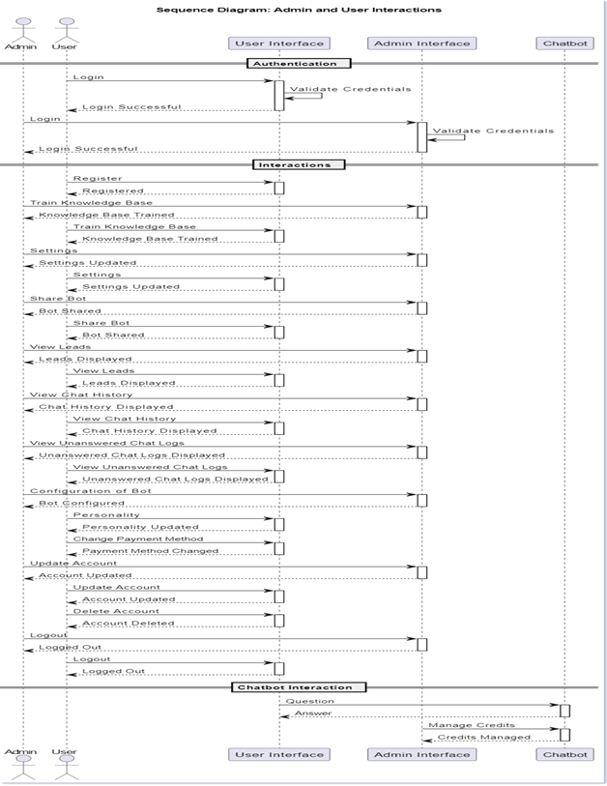

Figure 5. 6: Sequence Diagram

# CHAPTER 6

# System Implementation

After successfully designing all the previous phases of development that were the first steps in developing a system, now the final approach is to develop the system according to the UML visualization of the intended system. In this section, software develops just coded the system according to the diagrams and the technologies which are used here are mentioned below:

## 6.1. System Tools and Technology

The tools and technologies used are given as follows:

* Vue3.js
* Intertia.js
* Laravel
* Chat-fast API
* MySQL
* Vs Code
* NAVICAT

### 6.1.1. VS CODE

Visual Studio Code, commonly known as VS Code, is a free, open-source code editor developed by Microsoft. It supports a wide range of programming languages and comes with built-in features such as debugging, Git control, syntax highlighting, intelligent code completion, snippets, and code refactoring. VS Code is highly customizable, allowing users to extend its functionality through a vast library of extensions available in the Visual Studio Code Marketplace. Its lightweight design, combined with powerful features, makes it a popular choice among developers for both web and software development.

### 6.1.2. NAVICAT

NAVICAT is a comprehensive database management and development software designed to work with various database systems, including MySQL, MariaDB, PostgreSQL, SQLite, Oracle, and SQL Server. It offers a user-friendly interface with tools for database design, data manipulation, SQL editing, and data migration. NAVICAT simplifies complex database tasks with features such as data visualization, import/export capabilities, and secure connections. Its robust functionality and ease of use make it an ideal tool for database administrators, developers, and analysts to manage and interact with databases efficiently.

## 6.2. Class Diagram

This class diagram outlines a phone company structure involving core classes like **PhoneCompany**, **Customer**, **PhonePlan**, **Billing**, **ServiceArea**, **CustomerSupport**, Employee, and Promotion. **PhoneCompany** manages customers, **plans**, and **bills**. Customer subscribes to **PhonePlan** and links to Billing, while **ServiceArea** defines operational regions. **CustomerSupport** handles issues, **Employee** manages tasks, and **Promotion** offers discounts on plans.

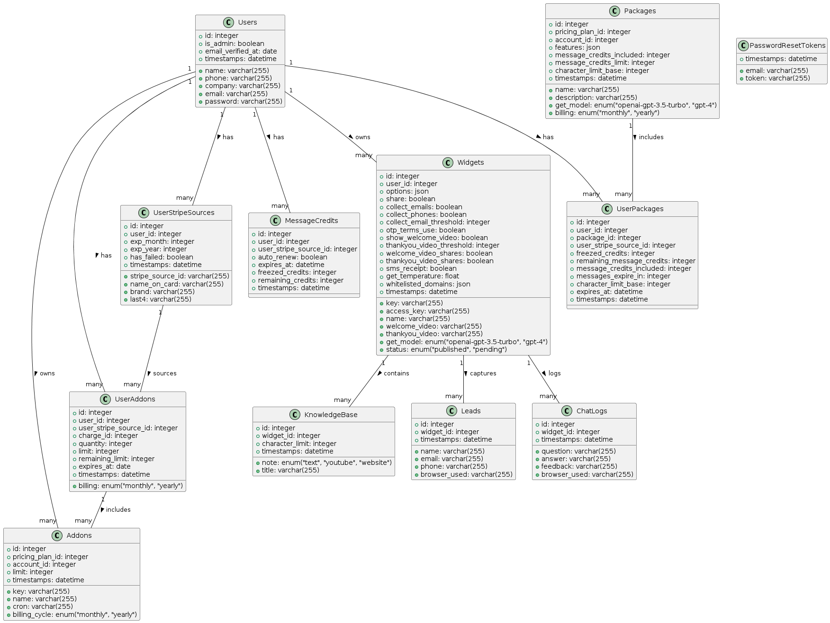

Figure 6. 1: Class Diagram

## 6.2. Deployment Diagram

The diagram illustrates the architecture of a chatbot system. It consists of a Chatbot Server, Database Server, and an External Knowledge Base. The Chatbot Server includes components such as Conversation Tracker, Dialog Engine, NLP Module, and ActionExecutor, which communicate over HTTP. The Browser operates as the user interface, sending requests from the Front-End Client to the Chatbot Server, which in turn interacts with the Database Server and External Knowledge Base to process and respond to user queries.

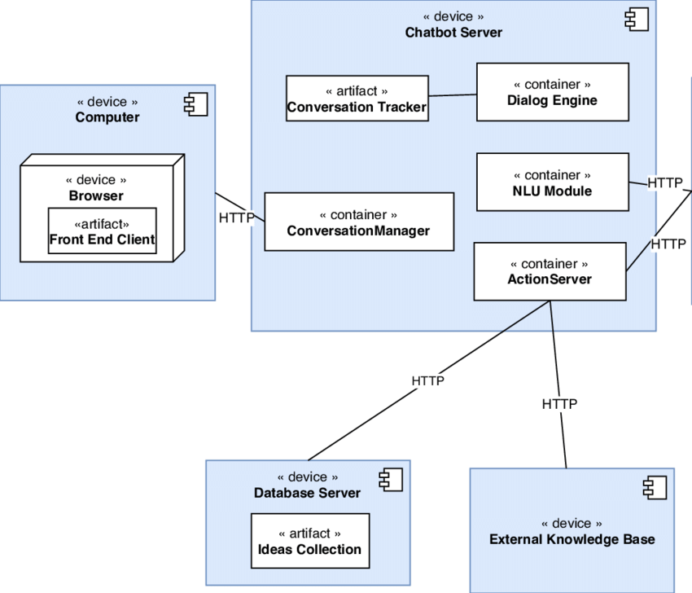

Figure 6. 2: Deployment Diagram

# CHAPTER 7

# System Testing

Software testing is performed to verify that the software system does what it is supposed to do and to ensure that the software system is defect free by using finite test cases. Each test case is selected by the software tester. Test case is a set of actions that are executed to verify a particular functionality of the software system under different circumstances. They can apply to any software system, can use manual testing, can use automated testing and can also use test case management tool. Software testing is performed to identify errors, bugs and any missing requirement in the system in contrast to actual requirement.

## 7.1 White Box Testing:

White box testing or glass box testing is an approach that allows tester to verify the internal structure of the software like coding and integration with internal system. Basic goal of white box testing is to verify the working flow for a software system rather than just like functionality in the black box testing.

As white box testing has advantage like it cover almost the whole system and provide coverage for testing. But also has disadvantages like it is very expensive, very time-consuming and requires professional resources. To perform white box testing testers must have code or programming knowledge. Following is the white box testing type:

* Unit testing
* Testing for memory leaks
* White box penetration testing
* White box mutation testing

## 7.2 Black box Testing:

In black box testing no prior knowledge of internal system is needed during testing. As it is based on user perspective, so concerned with input and output of the program. Testers give input than evaluate the output of the system.

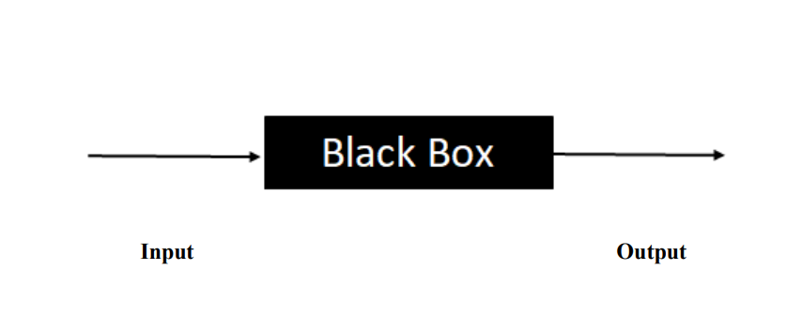

Figure 7. 1: Black Box Testing

Input Output Black box testing is also called behavioral testing. Test cases used for black box testing can be functional and non-functional. But mostly use functional test case.

* Functional testing
* Non-functional
* Regression testing

Following is the other type of testing:

* Scenario based Testing.
* Equivalence Based Testing
* Boundary valued Testing
* Accessibility Testing
* State Transition Testing

## 7.3: Verification

Verification is a process in which we check about the product meet all the system specifications. And We built the right product? We get all the answer about these questions in the verification process. This is an often-internal process. Four methods we are going to implement on our product for the verification process are as follows:

* Inspection
* Demonstration
* Test
* Analysis

## 7.4: Validation

Validation is a process in which we analyze the data gathered throughout the design and manufacturing of the product to confirm that each process produces a product with standard quality. We perform the validation process on our product to confirm that the product meets user expectations and concerns about building the right product.

## 7.5: Adopted Methodology

#### 7.5.1: Unit testing

Right from the start, we test the whole system in the sense that we test aspects of each small unit of the system with reference to its intended functionality. Before unit testing is carried out, it is expected to be completed at the development phase. This is considered in term of system Verification. Next comes the level of testing, which is again known as unit testing.

#### 7.5.2: Module Testing

Following unit testing, we encounter the next testing which is called module testing and in this testing each test object is tested as independent module without regarding to other objects of class, module and program. That is why we can test the login and logout module at the same time because they are intertwined. In addition, after successfully assembling a certain module, procedures and mechanisms are put in place to ensure that no other problem occurs again. After a completed testing of a specific module, there is a move to other testing.

#### 7.5.3: Integration testing

System integration testing is a phase in which the different modules of the system are combined in a group then testing is done. Integration testing assists in identifying system problems like for instance: a damaged database schema and misplacement of cache. It is considered in terms of system verification. Lastly at the end of each module, integration testing was conducted to ensure the respective modules were compatible with each other.

#### 7.5.4: System testing

Finally, system testing is done at the sub-levels and once all the sub-levels are tested then he tests the whole system at once. Also, black box testing is the other name of system testing. System testing typically only deals with the validation of the system. We conducted system testing on our system after all the modules of our system were complete to ensure it fully meets all its requirements.

#### 7.5.5: Acceptance testing

Acceptance testing is considered as the final phase of testing and its main purpose is to allow the system to be tested by the stakeholders. They make sure that the system corresponds to what they want or what they need. The acceptance testing is then completed for the system, after which the system is deployed after some time elapses.

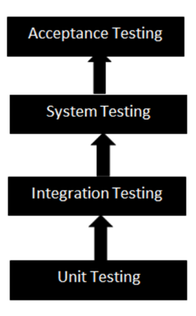

Figure 7. 2: Adopted Methodology

## 7.6. Test Cases

The table 7.1 shows the test case for File-Based Training:

Table 7. 1: Test Case for File-Based Training

|  |  |
| --- | --- |
| Component Name | File Upload Interface |
| Module Name | File-Based Training |
| Condition being tested | Upload various file formats |
| Expected Result | Files are successfully uploaded and processed |
| Success Scenarios | Files are correctly indexed, and content is searchable |
| Failure Scenarios | Files fail to upload, or content is not extracted |
| Test Result (Pass/ Fail) | Pass |

The table 7.2 shows the test case for Web Scraping Training:

Table 7. 2: Test Case for Web Scraping Training

|  |  |
| --- | --- |
| Component Name | Web Scraping Interface |
| Module Name | Web Scraping Training |
| Condition being tested | Extracting data from websites |
| Expected Result | Data is successfully scraped and organized |
| Success Scenarios | Data is cleaned and properly formatted |
| Failure Scenarios | Scraping fails or data is not organized |
| Test Result (Pass/ Fail) | Pass |

The table 7.3 shows the test case for YouTube Integration Interface:

Table 7. 3: Test Case for YouTube Integration Interface

|  |  |
| --- | --- |
| Component Name | YouTube Integration Interface |
| Module Name | YouTube Transcription-Based Training |
| Condition being tested | Automatic transcription of videos |
| Expected Result | Videos are transcribed and text is time-stamped |
| Success Scenarios | Transcriptions are accurate and linked to video segments |
| Failure Scenarios | Transcriptions are inaccurate or not linked to videos |
| Test Result (Pass/ Fail) | Pass |

The table 7.4 shows the test case for Embedding Widget Module:

Table 7. 4: Test Case for Embedding Widget Module

|  |  |
| --- | --- |
| Component Name | Widget Embedding |
| Module Name | Embedding Widget Module |
| Condition being tested | Easy to embed |
| Expected Result | Bubble will easy embed and link to website and provide support according to queries. |
| Success Scenarios | Bubble easily embed and link to website and provide support according to queries. |
| Failure Scenarios | Inaccurate Queries responses. |
| Test Result (Pass/ Fail) | Pass |

# CHAPTER 8

# Application Prototype

## 8.1: Home Page:

Hellodara.ai: AI-powered chatbot solutions - Watch Video | Pricing | Contact | Create Bot.

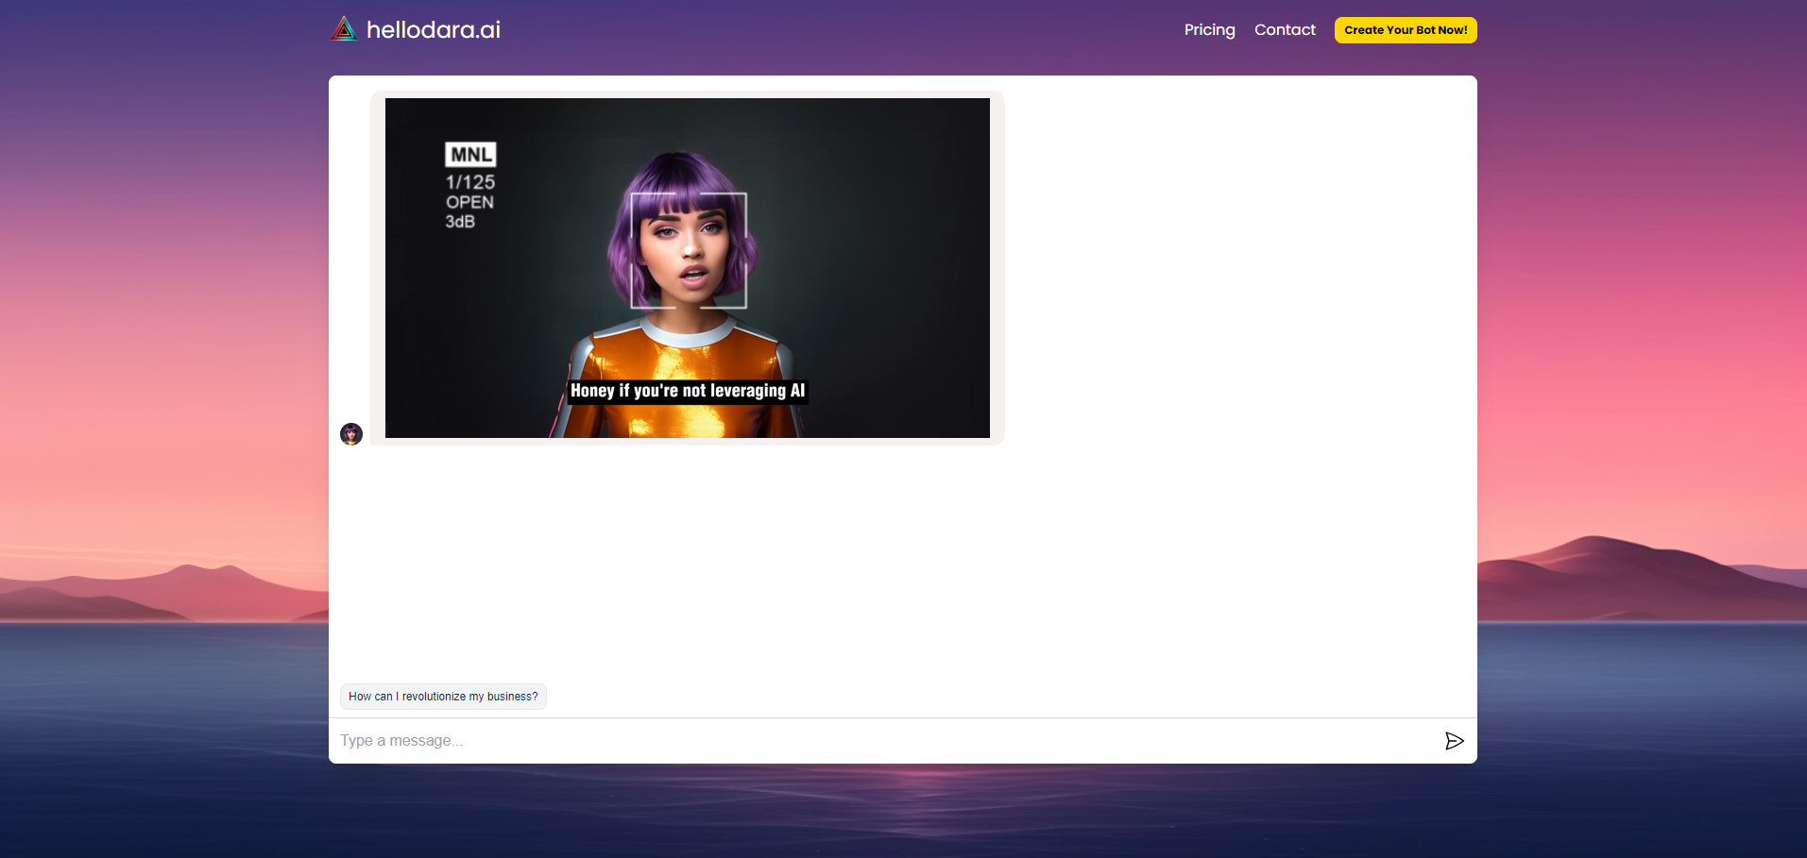

Figure 8. 1: Home Page

## 8.2: Login Page:

Hellodara.ai: Log in to your account or log in with Google.

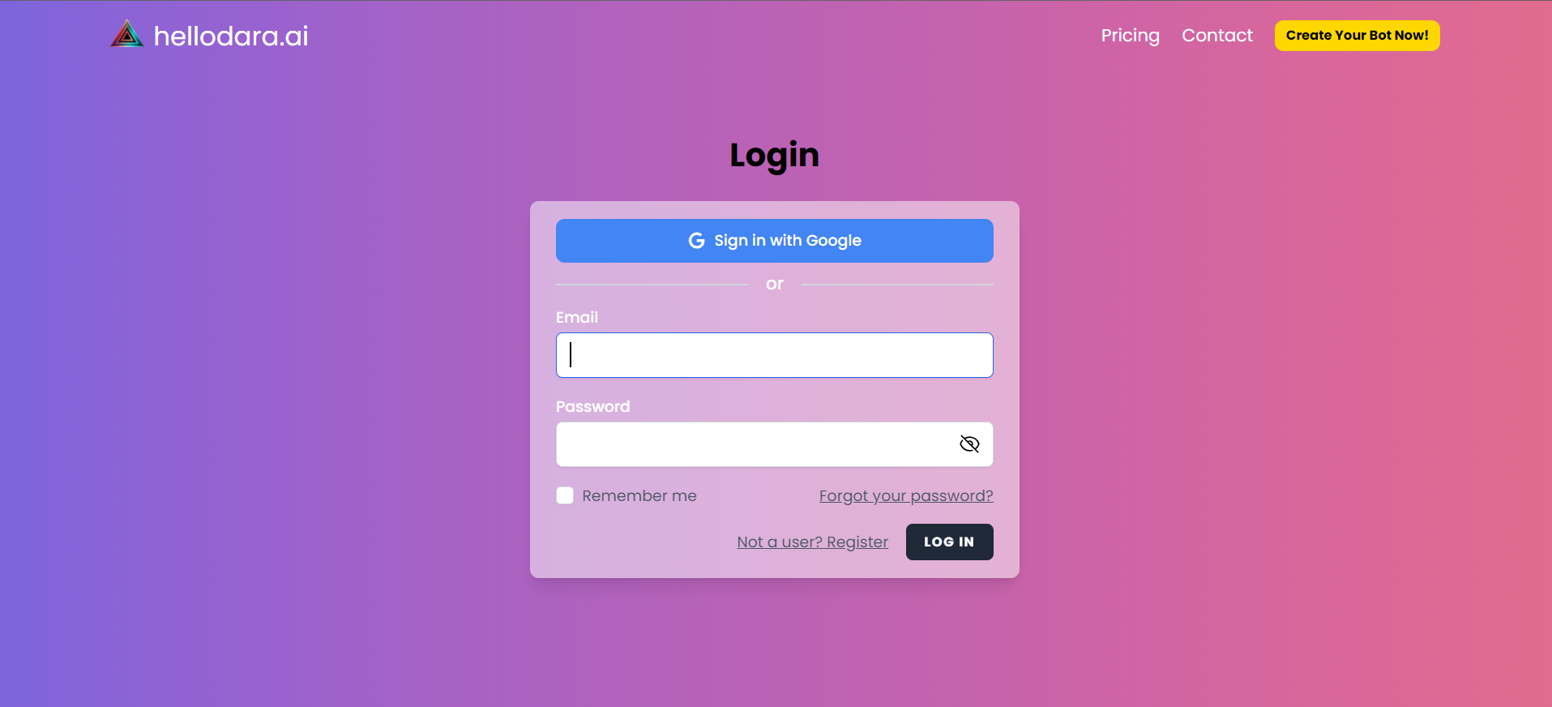

Figure 8. 2: Login Page

## 8.3: Forget Password:

Hellodara.ai: Forgot your password? Enter your email to reset it.

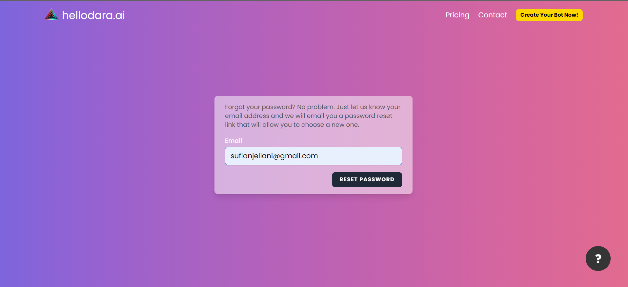

Figure 8. 3: Forget Password

## 8.4: Reset Password:

Hellodara.ai: Reset your password - Enter your email, new password, and confirm password. 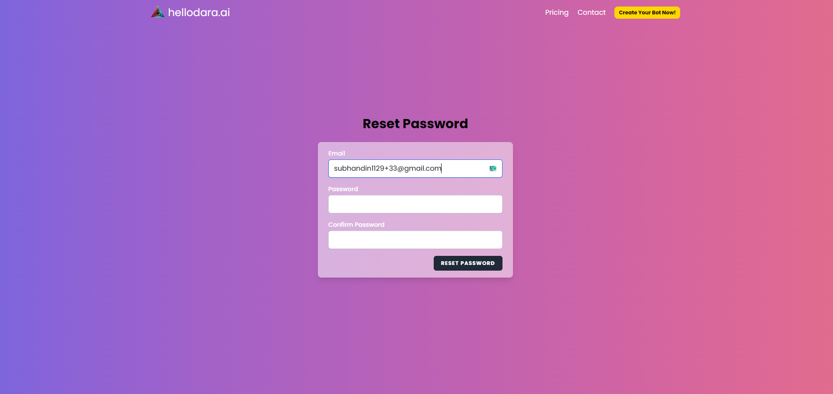

Figure 8. 4: Reset Password

## 8.5: Contact:

Hellodara.ai Contact Us: Enter your name, email, and message to get in touch.

Figure 8. 5: Contact

## 8.6: Pricing:

Hellodara.ai Pricing: Choose from Free (limited features) or Basic (more features), with additional Addons available.

Figure 8. 6: Pricing

## 8.7: Training: Upload files:

Hellodara.ai Training Files: Upload files here to train your chatbot.

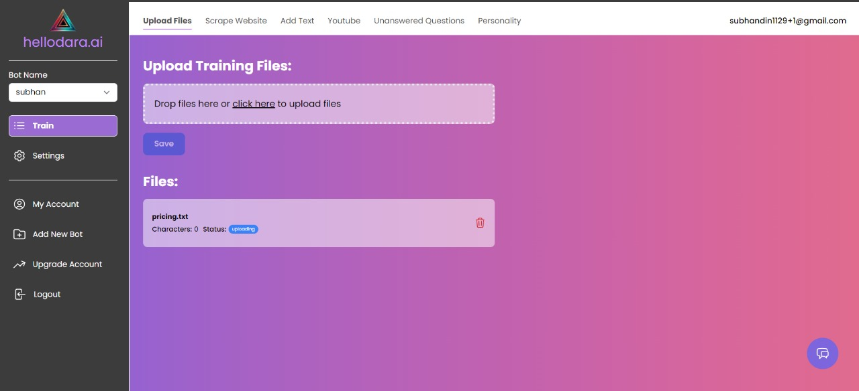

Figure 8. 7: Upload Files

## 8.8: Training 🡪 Add Text:

HelloDara.ai Add Text: Input text data to train your chatbot.

Figure 8. 8: Training Add Text

## 8.9: Training 🡪 Scrape Website:

HelloDara.ai Website Scraping: Input a URL to scrape website data.

Figure 8. 9: Training Scrape Website

## 8.10: Training🡪Transcribe YouTube:

HelloDara.ai: Enter a YouTube link to transcribe and train your chatbot.

Figure 8. 10: Training Transcribe YouTube

## 8.11: Training 🡪 Personality of Bot:

Boat Personality: Model and temperature status displayed.

Figure 8. 11: Training Personality of Bot

## 8.12: Training: Unanswered Questions:

Training Unanswered Queries: Incorporating unaddressed questions to enhance the chatbot's capability during training.

Figure 8. 12: Training: Unanswered Questions

## 8.13: Settings:

HelloDara.ai Settings: Customize avatar, name, and welcome message.

Figure 8. 13: Settings

## 8.14: Appearance:

HelloDara.ai Appearance: Customize your chatbot's appearance with various options.

Figure 8. 14: Appearance

## 8.15 Opt-in IN:

HelloDara.ai Opt-in: Set message frequency and collect email addresses.

Figure 8. 15: Opt-in IN

## 8.16 Share Bot:

HelloDara.ai Share Bot: Easily distribute your bot with a generated link, whitelisting authorized websites for sharing.

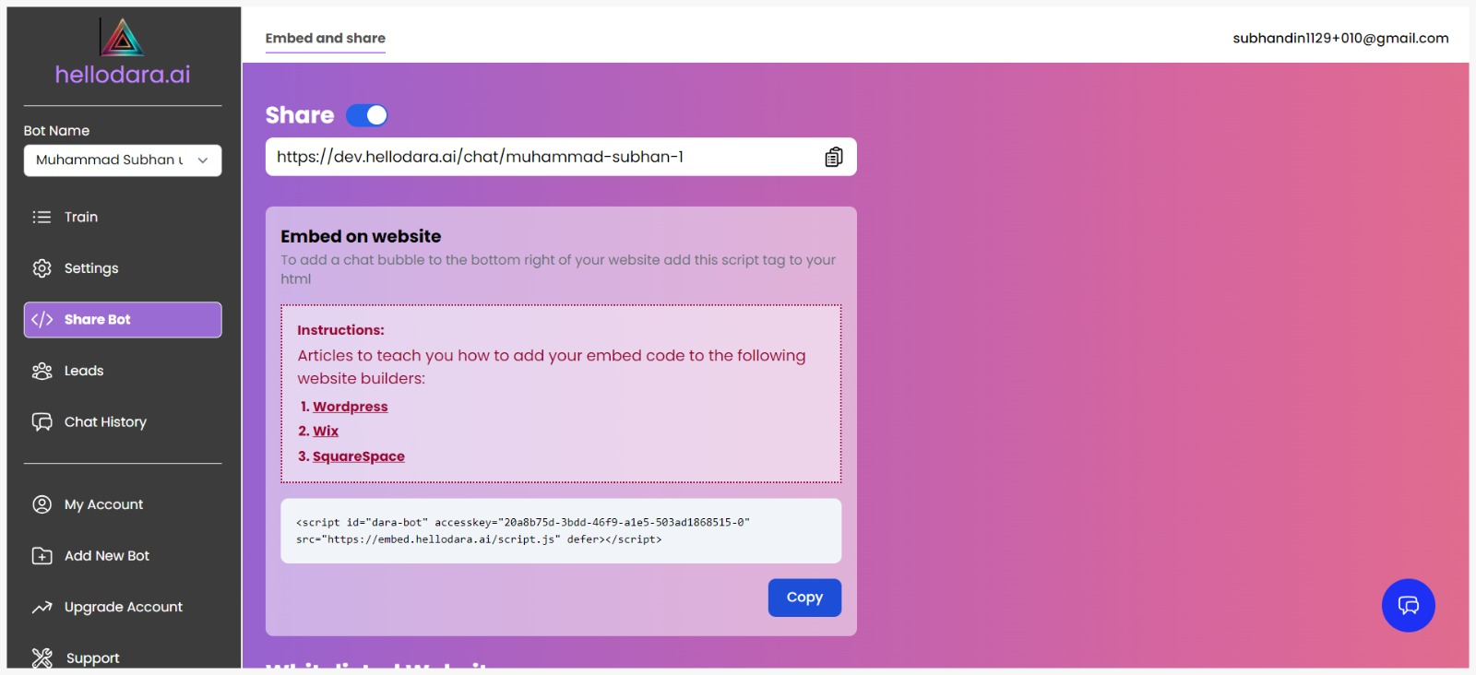

Figure 8. 16: Share Bot: Embed and Share

Figure 8. 17: Share Bot: Whitelisted Websites

## 8.17: Leads:

HelloDara.ai Lead Page: Collect leads with email and contact number fields.

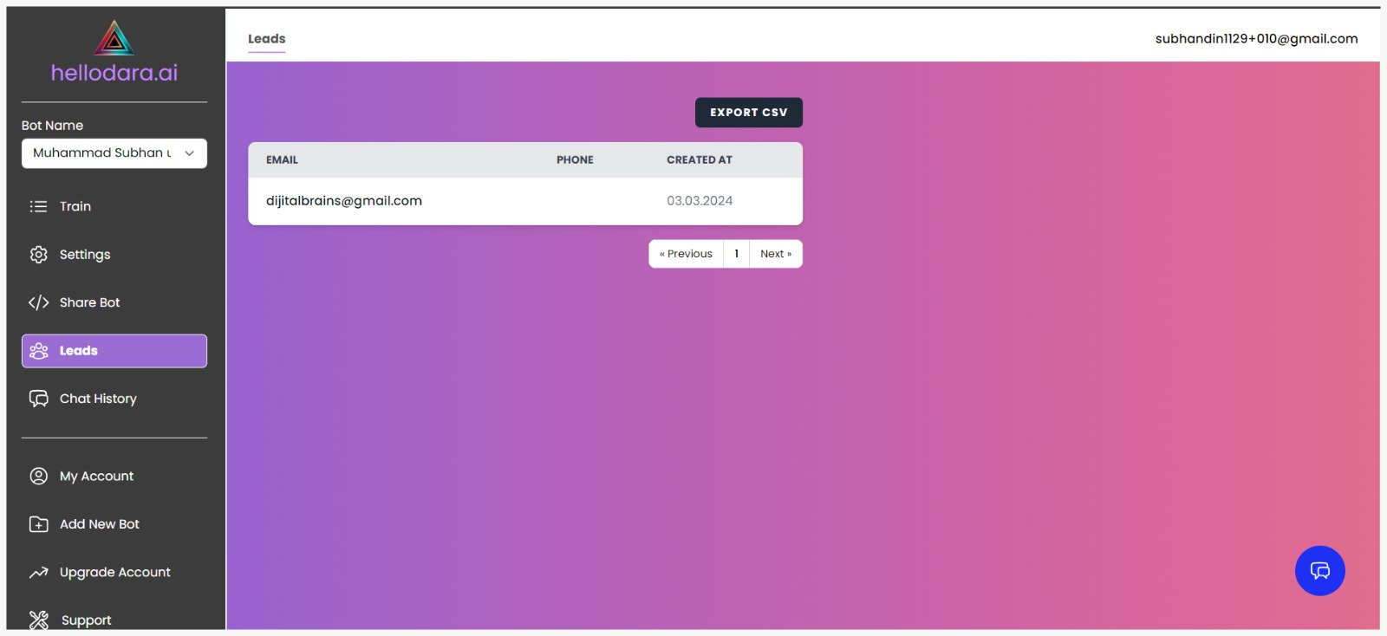

Figure 8. 18: Leads

## 8.18: Chat History:

HelloDara.ai Chat History: Review past conversations conveniently.

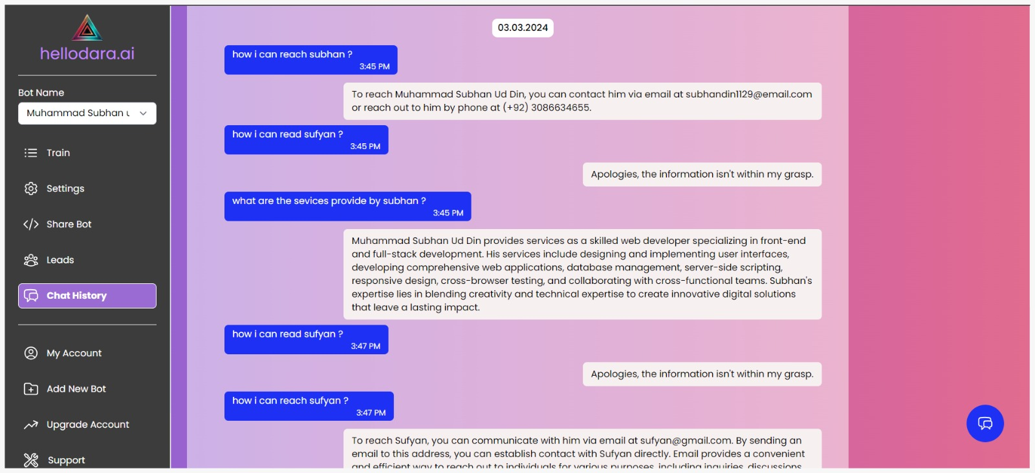

Figure 8. 19: Chat History

## 8.19: My Account:

HelloDara.ai My Account: Access and manage your account details easily.

Figure 8. 20: My Account – Billing

HelloDara.ai Subscription Management: Adjust your subscription plan and set message credits.

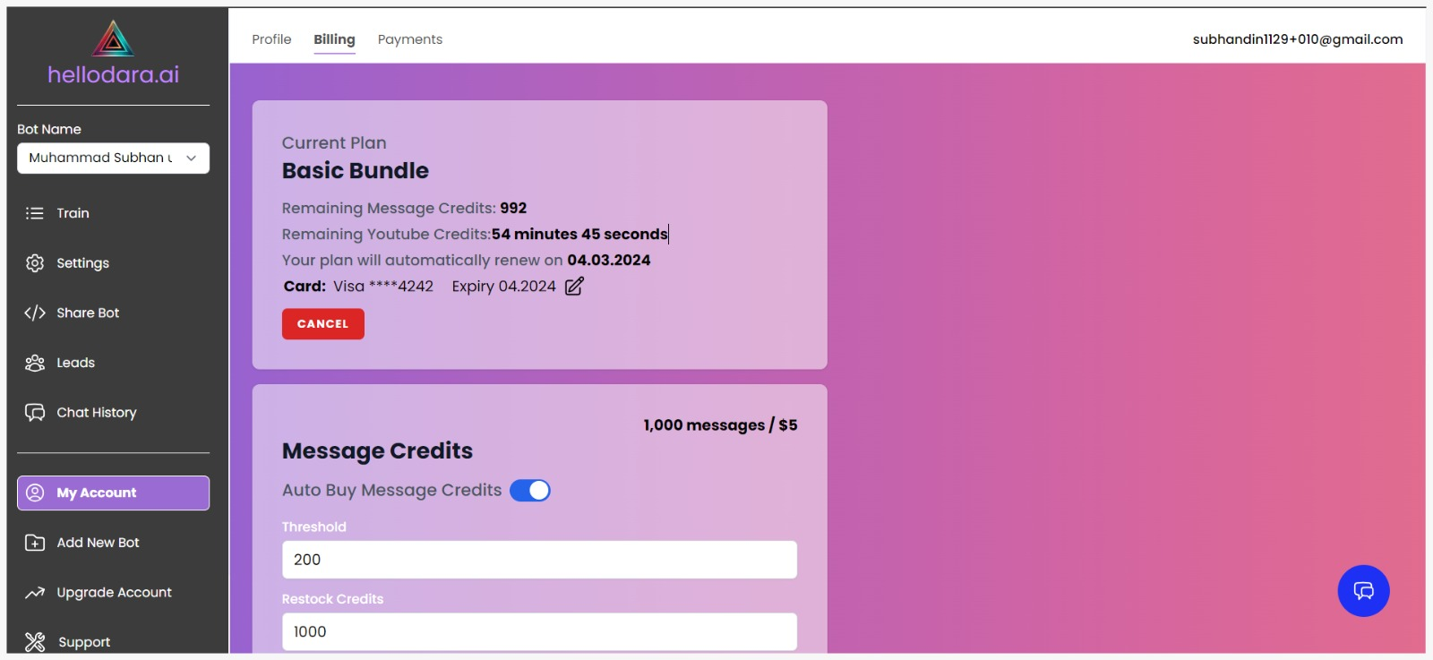

Figure 8. 21: My Account - Billing (Basic)

Figure 8. 22: My Account - Billing (Credits)

HelloDara.ai Profile Settings: Manage email, set password, and view profile details on your profile page.

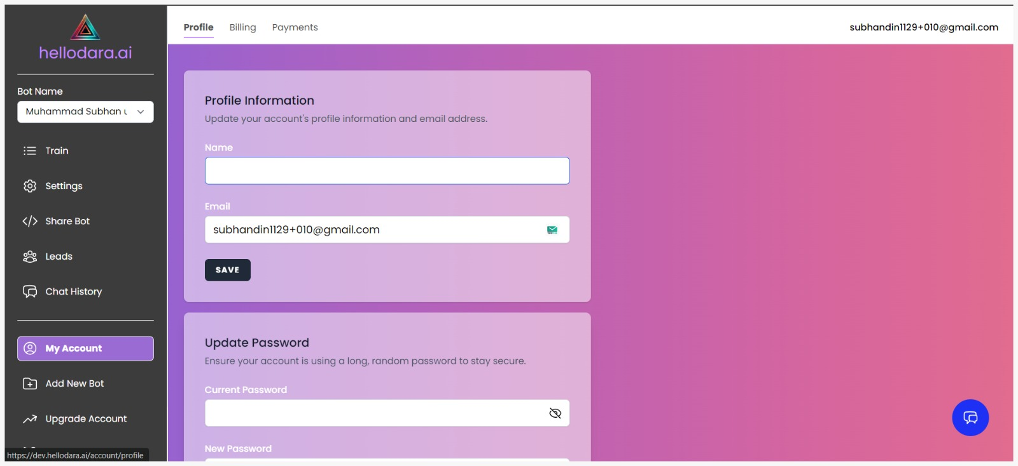

Figure 8. 23: My Account - Profile

## 8.20: Payments:

HelloDara.ai Payment Method: Add or update your payment details securely by card.

Figure 8. 24: Payments

## 

## 8.21 Create New Bot:

HelloDara.ai Create New Bot: Begin building your new bot with ease.

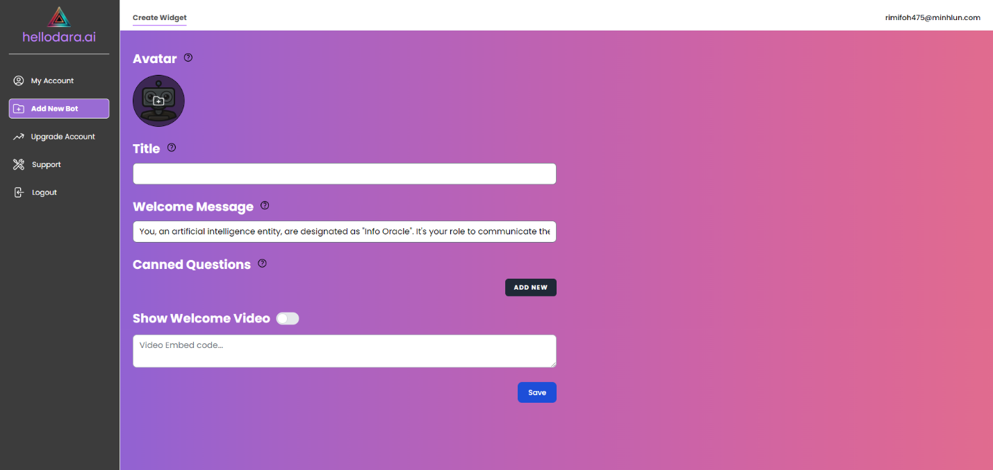

Figure 8. 25: Create New Bot

# References

[1] Salesforce Developer Documentation,” 2023.

[2] OpenAI Platform,” 2024.

[3] Speech Recognition · PyPI